#### Defining and Automating Provisioning of Infrastructure Architecture Patterns to IBM Public Cloud

# Tutorial

In just a few minutes, you will move through a brief introduction to Terraform, explore and apply IBM Cloud Terraform Provider, then use a Docker container to deploy an IaaS architecture to IBM cloud. Since the content is maintained in publicly in GitHub, you and your team can then extend their experience to continue deployments after the lab.

To learn more about deploying IBM Cloud IaaS capabilities with Terraform, check out these articles:

* [IBM Public Cloud Infrastructure Architecture](https://www.ibm.com/cloud/garage/architectures/public-cloud)
* [IBM Terraform Provider documentation](https://ibm-cloud.github.io/tf-ibm-docs/)
* [IBM Terraform Provider Docker File](https://hub.docker.com/r/ibmterraform/terraform-provider-ibm-docker)

Prerequisites: You will need to have the following in place before completing this tutorial

1. You must have an IBM Cloud account that can deploy infrastructure resources. The account is free and provides access to everything you need to develop, track, plan, and deploy apps. [Sign up for a trial](https://console.bluemix.net/registration/?cm_mmc=IBMBluemixGarageMethod-_-MethodSite-_-10-19-15::12-31-18-_-bm_reg). The account requires an IBMid. If you don't have an IBMid, you can create one when you register. IBM Cloud account that can deploy infrastructure resources
2. An IaaS API key and username for the IBMid.
   1. To obtain these values in IBM Cloud, navigate to Infrastructure > Account > User List and find your user. Under the column **API KEY**, click the **View** link and you will find your IaaS API key and username.



1. Existing and deployed Private and Public VLANs. You will need the VLAN IDs for the deploy process.
   1. [Instructions to request VLAN deployment](https://console.bluemix.net/docs/infrastructure/vlans/getting-started.html#getting-started-with-vlans)
   2. Obtain the VLAN ID using the API or CLI command, or by obtaining the VLAN number from the URL after you navigate to Infrastructure > Network > IP Management > VLANs in the GUI.

Tutorial 1

Step 1: Welcome to Terraform 4

Step 3: Set up your environment 6

Step 4: Run Terraform Container 7

Step 5: Understand the Architecture 8

Step 6: Review Terraform files 11

Step 7: Update deployment variables 13

Step 8: Deploy to IBM Cloud 15

# Step 1: Welcome to Terraform

In this section, we will review available documentation for the technology platform, architectures and IBM tooling and services. It is important to understand how Terraform can be used before applying it to technologies with IBM services.

## Review Terraform References

This lab is not intended to instruct in Terraform. Rather, a review of readily available resources is provided for your review. Also, during the lab you may find it helpful to review to the material to further understand the content of the examples and a manner to extend it for your own use. Take some time to review these references:

* “[Terraform, Up and Running](https://www.terraformupandrunning.com/)” By Yevgeniy Brikman
* [Terraform Google Group](https://groups.google.com/forum/#!forum/terraform-tool)
* [HashiCorp’s Terraform Website](http://terraform.io/)
* [HashiCorp’s Terraform provider GitHub](https://github.com/hashicorp/terraform)

## Step 2: Introduction to the IBM Cloud Terraform Provider

In this task you will review all of the relevant documentation on IBM Cloud provider for Terraform. Please take a few minutes to review the information, repositories and Docker hub information. There are also two white papers on using other IBM services and Terraform. The reference material will be used in later tasks. Click the title of each reference to open the link.

* [IBM Cloud Terraform Provider v0.12.0 Documentation](https://ibm-cloud.github.io/tf-ibm-docs/v0.12.0/)  
  This page contains the documentation on the latest version of the IBM cloud provider plugin. It contains descriptions for data, resources and variables used with the provider.
* [IBM Cloud Provider GitHub](https://github.com/IBM-Bluemix/tf-ibm-docs)  
  This repo contains the latest IBM cloud provider code you can use with the terraform run time to deploy resources in IBM cloud.
* [IBM Cloud Provider Dockerfile on Docker Hub](https://hub.docker.com/r/ibmterraform/terraform-provider-ibm-docker/)  
  This Docker file is used to build the image with terraform core version 0.11.0 and terraform IBM Cloud provider version 0.12.0.
* [IBM Cloud Provider Dockerfile in GitHub](https://github.com/IBMTerraform/terraform-provider-ibm-docker)  
  This Docker file is maintained in GitHub and used to build the image with terraform core version 0.11.0 and terraform IBM Cloud provider version 0.12.0.

## Terraform related IBM services and tools

* [Full Stack deployment with IBM UrbanCode Deploy and Terraform](https://developer.ibm.com/urbancode/2017/08/22/full-stack-provisioning-urbancode-deploy-terraform/)
* [Terraforming the IBM Cloud with IBM Cloud Automation Manager](https://developer.ibm.com/cloudautomation/2018/07/09/terraforming-ibm-cloud-ibm-cloud-automation-manager/)

# Step 3: Set up your environment

Install Docker: To run the IBM Terraform Provider Docker runtime, you will need an environment to build/deploy the Docker container. You can use any of these environments or your own Docker environment.

* [Set up your local Docker environment](https://docs.docker.com/get-started/#prepare-your-docker-environment)
* [IBM’s DevOps Toolchain and Kubernetes Services](https://www.ibm.com/cloud/garage/tutorials/use-develop-kubernetes-app-toolchain)
* Your own hosted Docker environment with the [IBM Cloud Provider Dockerfile](https://hub.docker.com/r/ibmterraform/terraform-provider-ibm-docker)

This tutorial will provide screen captures and explain how to perform when running on your desktop. If you choose another option, you can easily use the tutorials above when performing these steps.

# Step 4: Run Terraform Container

## Start Shell

Start a shell by the process of your operating system. The views of these steps use a Linux-type operating system and may be different for your operating system.

## Verify Docker is Running

Enter the command **docker -v** to output the current Docker version.

Pull the latest image of the IBM Cloud Provider Dockerfile from Docker Hub using the command

Enter the command **docker pull ibmterraform/terraform-provider-ibm-docker**



## View all images

Enter the command **docker images** to display all Docker images.



## Start the IBM Cloud Terraform provider container

To start and interact with the container, enter the command:

**docker run -it ibmterraform/terraform-provider-ibm-docker:latest /bin/bash**

and click return



## Clone the Terraform repository

While you are still in the Docker container, in the terminal window enter:

**git clone https://github.com/ibm-cloud-architecture/refarch-public-iaas-tutorial.git**

Note: The numbers in the response (Counting objects, compressing objectives, Total, etc) may change for your particular lab. You should receive “Done” as the final response to a successful execution.

# Step 5: Understand the Architecture

In this section you will review the architecture that represents the terraform files you will use to deploy resource to IBM Cloud. Then, you will walk through each section of the Terraform files to understand what the script will provision into IBM Cloud.

## Access GitHub repository

Open a browser and navigate to the public GitHub repository:

<https://github.com/ibm-cloud-architecture/refarch-public-iaas-tutorial.git>

## Deployable Infrastructure Architecture

The example architecture shown in the GitHub repository's README.md file (see below) is designed to support virtual server bursting in IBM Cloud using an existing virtual network and security architecture. The scripted Terraform configuration for this example architecture deploys a series of multi-tenant virtual servers connected to public and private networks and two common file storage services that correspond to their respective virtual server.

The number of virtual servers to be deployed and any post-deployment installation and configuration are parameterized and set based on your preferences at deployment time.

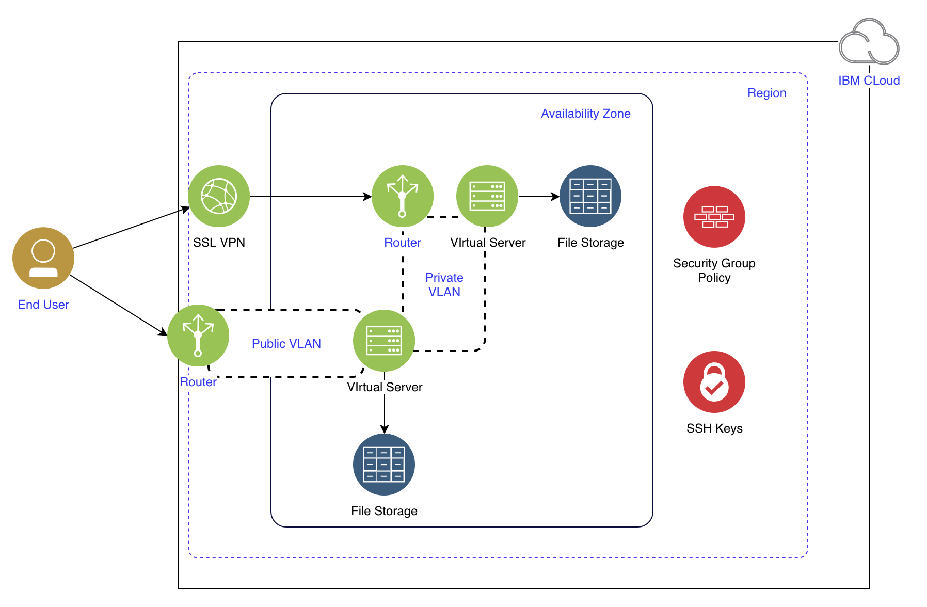

## 

## Architecture components

|  |  |  |  |
| --- | --- | --- | --- |
| Component | Description | IBM Service | Provider Resource |
| [VSI](https://console.bluemix.net/docs/vsi/vsi_index.html#getting-started-tutorial) | Virtual server instance. One or more virtual servers deployed as multi-tenant instances into two availability zones. | Public VSI | ibm_compute_vm_instance |
| [File storage](https://console.bluemix.net/docs/infrastructure/FileStorage/index.html#getting-started-with-file-storage) | Two instances deployed as a common storage services for the virtual servers in that zone. | File Storage | ibm_storage_file |
| [Security group](https://console.bluemix.net/docs/infrastructure/security-groups/sg_index.html#getting-started-with-security-groups) | Two groups. One group with policies for the virtual servers attached to the public network that allows limited messages on that network. A second group with policies for all virtual servers to limit communications between virtual servers on the private network. | Security Group | ibm_security_group  ibm_security_group_rule |
| [VLAN](https://console.bluemix.net/docs/infrastructure/vlans/getting-started.html#getting-started-with-vlans) | Virtual Local Area Network. Public allows communications to the public internet. Private limits communications between the virtual servers and resources on that network. | Public or Private VLAN | ibm_network_vlan |
| [Zone](https://www.ibm.com/blogs/bluemix/2018/06/expansion-availability-zones-global-regions/) | The zone is a physical area of a region that supports high availability. | Data Center | datacenter |
| [Region](https://www.ibm.com/blogs/bluemix/2018/06/expansion-availability-zones-global-regions/) | A single geographic region where both availability zones are located. | IBM Cloud Region | us_south |
| [SSH Key](https://console.bluemix.net/docs/infrastructure/ssh-keys/index.html#getting-started-tutorial) | A service that manages SSH keys published in IBM cloud. | Open VPN | ssh_key |
| [SSL VPN](https://console.bluemix.net/docs/infrastructure/iaas-vpn/about-vpn.html#ssl-vpn-subnet-limit) | A VPN to connect users to private VLANs | SSL VPN | sslvpn |

## 

# Step 6: Review Terraform files

This section will walk through the content in each of the terraform configuration files. They use the **IBM provider** terraform plugin for determining what is written in each code block. We will step through each of the files in the GitHub repository.

## provider.tf

This file declares which Terraform providers are used in this configuration and provides any provider specific information. The provider must be configured with the proper credentials before it can be used. In this case, the IBM Cloud infrastructure user name and API key. The API key is required to provision infrastructure resources.

## access_control.tf

This file creates a new SSH key from argument values and enters it into the IBM Cloud SSH key store. It can be reused as necessary. In this configuration, it will be used for all of the deployed virtual servers. It requires a public SSH key.

## storage.tf

This file contains the information to create two NFS-based file storage instances in the same data center. It is then mounted to each of the virtual servers deployed.

Note: Terraform does not execute the blocks of code in order of appearing the files. Rather it loads all to memory and determines, based on explicit of implicit dependencies, the order to run. For example, the virtual server blocks require the storage and SSH keys in place.

## 

## security.tf

This file contains the blocks to create two security groups and associated security policies. Each are used to limit communications of associated virtual servers on the public and private networks, respectively. The security group rules manage ingress and egress traffic to the virtual server instance.

## compute.tf

This file contains the blocks to create two **sets of virtual servers** with the following properties:

* the total number of virtual servers is based on the “compute_count” variable
* the hostname naming convention produces unique names based on indexing from the count values
* the file storage and SSH key values refer to the ID of the storage an ID for each resource, which is referenced in the following syntax: **resource_type.rsource_name.id**. See the **file_storage_ids** in in this block

## variables.tf

This file contains the variables used by the .tf files. Several default values are left blank as they are respective to the user and the zone to provision. The remaining variables can be left as default for deployment unless changed otherwise. This pattern can be parameterized to be deployed to multiple data centers or regions, or to accommodate resources (i.e. VLANs).

# Step 7: Update deployment variables

Note: If you have never used the “vi” tool to edit files in Linux, then review this [vi tutorial](https://developer.ibm.com/tutorials/l-lpic1-103-8/) to get familiar with the commands.

The Terraform configuration includes key variables that you will provide values for. The following steps will enable you to add the values to those variables.

In the terminal inside your container, change directory to the cloned repository using the command **cd Tutorial.** Click enter. To open *variables.tf***,** type the command **vi variables.tf** and click enter. To edit, enter **i** and use the arrow keys to move the cursor to your variables.

*Do not exit the terminal or vi until the instructions direct.*

## Enter your IaaS API Key

Locate the variable **iaasapikey** in the *variables.tf* file. Paste your key as the variable’s **default** value in between the double-quotes.



## Enter your IaaS user name

Locate the variable **iaasusername** in the *variables.tf* file. Paste your IaaS user name as the variable's **default** value in between the double-quotes.



Add the public SSH key value  
Generate a SSH key to use for the tutorial. Return to the terminal and locate the variable **ssh_key** in the *variables.tf* file. Paste the copied public key as the variable’s **default** value in between the double-quotes.



## Add the Public and Private VLANs

Locate the variables **publicvlanid** and **privatevlanid**. Paste the respective [VLAN IDs](https://console.bluemix.net/docs/infrastructure/vlans/about-vlans.html?cm_mmc=IBMBluemixGarageMethod-_-MethodSite-_-10-19-15::12-31-18-_-vlan-identification#vlan-identification).



Add the availability zone and region

Locate the variables **availability_zone** and **region**. Paste the respective [availability zone and region](https://console.bluemix.net/docs/containers/cs_regions.html?cm_mmc=IBMBluemixGarageMethod-_-MethodSite-_-10-19-15::12-31-18-_-regions-and-zones#regions-and-zones) for this deployment.



Finish editing the variables.tf file

Click "esc" and then notice the cursor in the lower left corner of the terminal window. This will close your edits. To save the changes and close the *variables.tf* file, enter **:wq** and click enter.

Open the *variables.tf* file with command **vi variables.tf** and verify your changes were saved. If successful, click "esc", type **:q!**, and click enter to exit without changes. If not, repeat the steps.

# Step 8: Deploy to IBM Cloud

## Initialize the Terraform provider

The **terraform init** command is used to initialize a “working directory” containing Terraform configuration files. This is the first command that should be run after writing a new Terraform configuration or cloning an existing one from version control. This step will move to the clone directory to start the provider.

In the terminal, enter the command **terraform init**:

Note: You should still be in the TFDemo directory.



# You can now begin working with the Terraform configuration file. If you ever set or change modules or backend configuration for Terraform, rerun this command to reinitialize your working directory. If you forget, other commands will detect it and remind you to do so if necessary.

## Run Terraform Plan

Run **terraform plan** to review all resources will get provisioned and identify any errors.

In the terminal, enter the command **terraform plan**:



## Run Terraform Apply

If no errors are identified in the plan activity above, you should now run *apply* to provision the resources into IBM Cloud. In the terminal, enter the command:

In the terminal, enter the command **terraform apply**:

When prompted, enter **yes** to perform the actions.



Confirm the details of your deployment, enter **terraform show** and click enter. Review the list of resources and details.

## Run Terraform Destroy

Once you verified your deployment, clean the environment and destroy all of the resources created during the *apply* activity above. In the terminal, enter the command **terraform destroy**.

## Congratulations!

You deployed an IaaS architecture to IBM Cloud with automation!